
CSD 454 COMPUTER VISION
Using VJEPA2 for AR navigation and making it suitable for mobile deployment


Faculty mentor(s)
DR. SUMIT SHEKHAR & DR. SAURABH JANARDAN SHIGWAN
Department of Computer Science and Engineering

Acknowledgement
I would like to express my sincere gratitude to all those who contributed to the successful completion of this project.
First and foremost, I am deeply thankful to Dr. Sumit Shekhar and Dr. Saurabh Janardan Shigwan, whose invaluable guidance, support, and encouragement were instrumental throughout the project. Their insights and expertise helped shape the direction and quality of this work.
My appreciation goes to my friends and colleagues for their constant support, helpful discussions, and feedback, which greatly enriched this project.
Without the support and contribution of all these individuals, the successful completion of this project would not have been possible.

Introduction
Enabling real-time scene understanding on mobile devices is essential for a broad range of augmented reality applications, including indoor navigation, obstacle avoidance, and virtual object anchoring, where system responsiveness depends critically on the speed and accuracy of the underlying perception models. Traditional approaches to visual odometry and obstacle detection rely on hand-crafted feature descriptors such as SIFT and ORB, or shallow convolutional networks trained on single tasks in isolation — methods that struggle to generalise across environments and fail to capture the temporal dynamics of moving cameras. More recent solutions leverage large Vision Transformers pre-trained on video data, achieving state-of-the-art accuracy in motion estimation and scene representation; however, these models demand computational resources far exceeding what commodity mobile hardware can sustain at 30 frames per second. Inspired by the Joint Embedding Predictive Architecture paradigm, which learns rich abstract representations by predicting latent features of masked regions rather than reconstructing raw pixels, both image-based and video-based variants have been proposed to address these limitations. Nevertheless, deploying such architectures directly on edge devices remains infeasible due to their parameter count and inference latency. Recent progress has shifted toward model compression strategies — in particular Knowledge Distillation — wherein a compact student network is trained to replicate the internal representations of a large pre-trained teacher, inheriting its perceptual richness at a fraction of the computational cost

Methodology
An AR app on a phone needs to know three things every ~33ms (at 30 FPS): how the camera moved, whether something is in the way, and what the scene looks like for localization. The best models that do this are giant Vision Transformers (hundreds of millions of parameters) that take 200-500ms per frame — far too slow. We try to reduce the number of parameters for easier deployment on our mobile phones.
We choose two very popular dataset(s) for our model in the training phase.
ARKitScenes — Apple's dataset of indoor scenes captured with iPad LiDAR. Provides RGB frames + camera trajectory (6-DoF pose over time). Obstacle labels come from annotations, or are estimated from motion speed (if speed < 0.15 m/s, the camera stopped — probably because something is blocking it).

TUM RGB-D — A robotics benchmark dataset from TU Munich. Provides RGB + depth images + precise 6-DoF ground truth poses using a motion capture system. Obstacle labels come directly from the depth map: if the center region has anything closer than 1.5 meters, that's an obstacle. This is more accurate than the ARKitScenes fallback heuristic.

The Data Flow along with the dimensions is represented in the following flow diagram
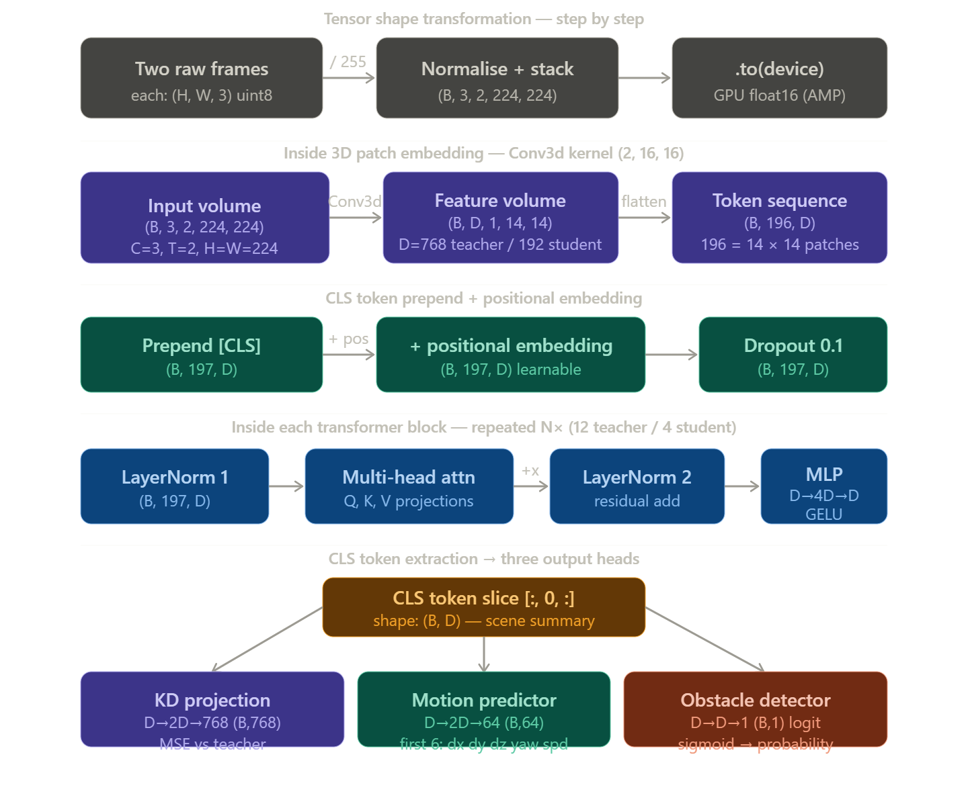

This flow chart is the birds eye view representation of the architecture and the whole
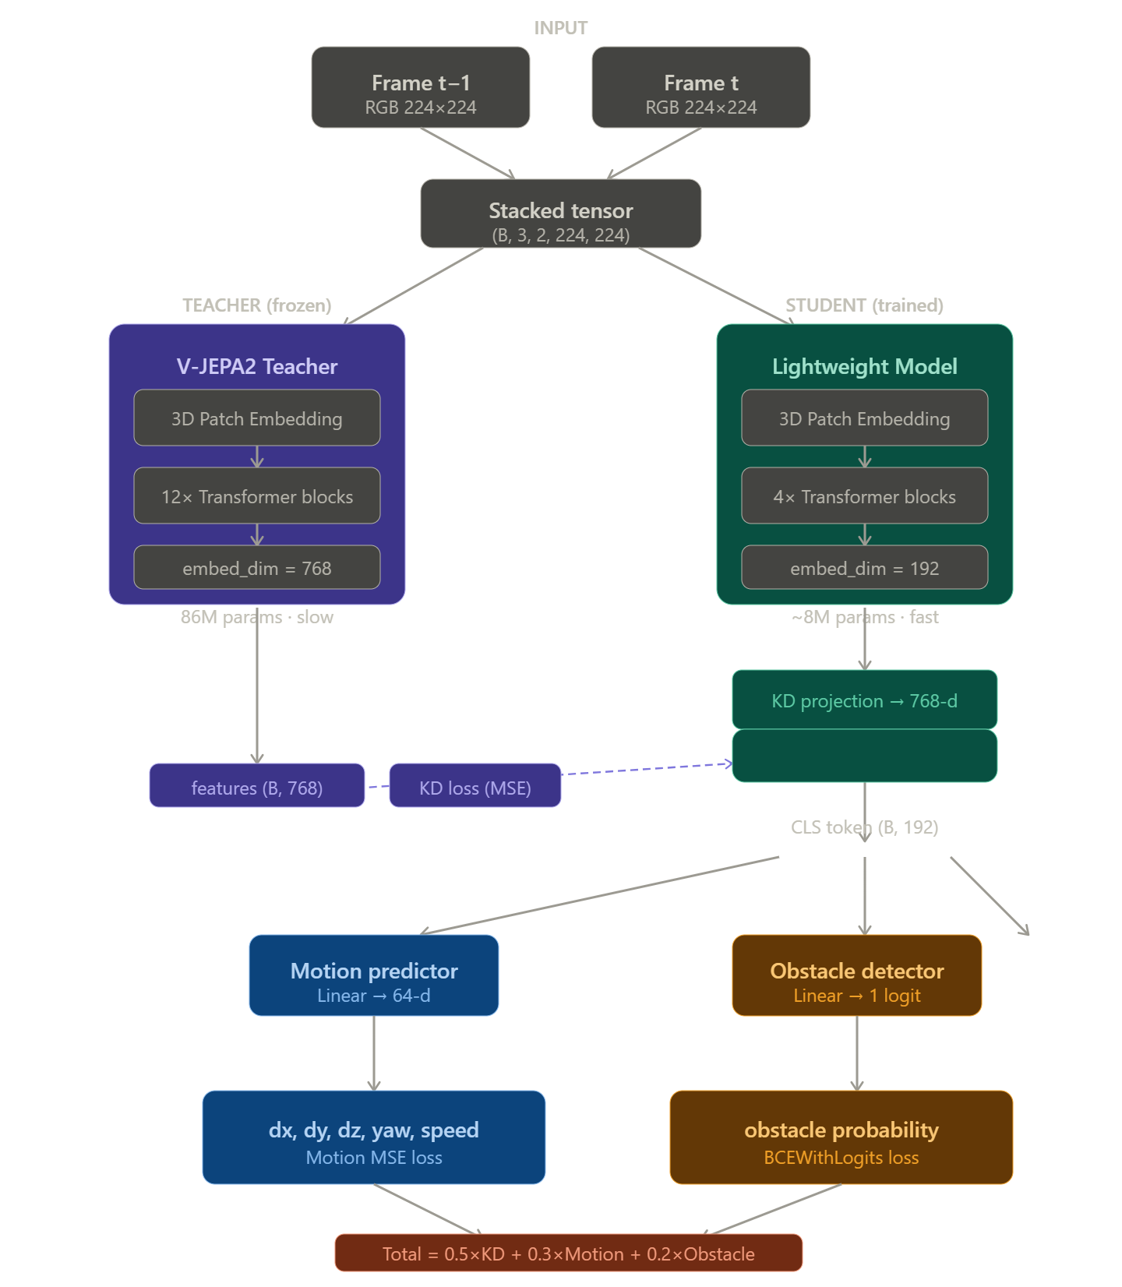

The Teacher Model: V-JEPA2
JEPA = Joint Embedding Predictive Architecture. V-JEPA2 is Meta's video understanding model. The key idea: instead of predicting pixels, it predicts abstract representations of masked video regions in a learned embedding space. This makes it excellent at understanding motion and scene structure.
Architecture inside the teacher:
- PatchEmbed3D — a single Conv3d layer with kernel (2, 16, 16). It treats two frames as a tiny video and extracts non-overlapping 3D patches. A 224×224 image with patch_size=16 gives 14×14 = 196 patches. With 2 frames, the Conv3d produces 196 tokens.
- [CLS] token — a learnable vector prepended to the patch sequence. After all transformer blocks, this one token summarizes the entire input. It's what the student tries to copy.
- 12 Transformer blocks — each block has Multi-Head Self-Attention (12 heads, embed_dim=768) followed by an MLP (768 → 3072 → 768 with GELU activation). LayerNorm is applied before each sub-layer (pre-norm style).
- Output: a single 768-dimensional vector from the CLS token.
Freezing the teacher is necessary because its weights are not updated during training. It acts as a fixed "oracle" — the student's job is purely to match its output.

The Student Model
Same structure but much smaller: embed_dim=192, only 4 transformer blocks, 6 attention heads. Has three output heads hanging off the CLS token:
Head | Architecture | Output | Loss
KD projection | Linear(192→384)→GELU→Linear(384→768) | 768-d features | MSE vs teacher
Motion predictor | Linear(192→384)→GELU→Linear(384→64) | 64-d (first 6 used) | MSE vs GT
Obstacle detector | Linear(192→192)→GELU→Linear(192→1) | 1 logit | BCEWithLogits

The Training Algorithm
In Knowledge Distillation work the teacher sees the same input as the student, produces its CLS embedding, and the student's KD projection is trained to match it via MSE loss. This forces the student to develop similar internal representations despite being 10× smaller.
Multi-task learning: The student simultaneously learns three tasks. The total loss is a weighted sum:
Loss = 0.5 × MSE(student_KD, teacher_features)
+ 0.3 × MSE(student_motion, ground_truth_motion)
+ 0.2 × BCEWithLogits(student_obstacle_logit, ground_truth_obstacle)
The weights (0.5, 0.3, 0.2) reflect priority — feature distillation is most important because it's the hardest and richest signal.
Optimizer: AdamW with weight decay 1e-4, different learning rates for different parts (patch_embed and transformer blocks at 1e-3, output heads at 2e-3 — the heads learn faster because they have a more direct supervision signal).
Scheduler: Cosine Annealing over 20 epochs — learning rate starts at its peak, smoothly decays to 1e-6. This avoids oscillation near convergence.
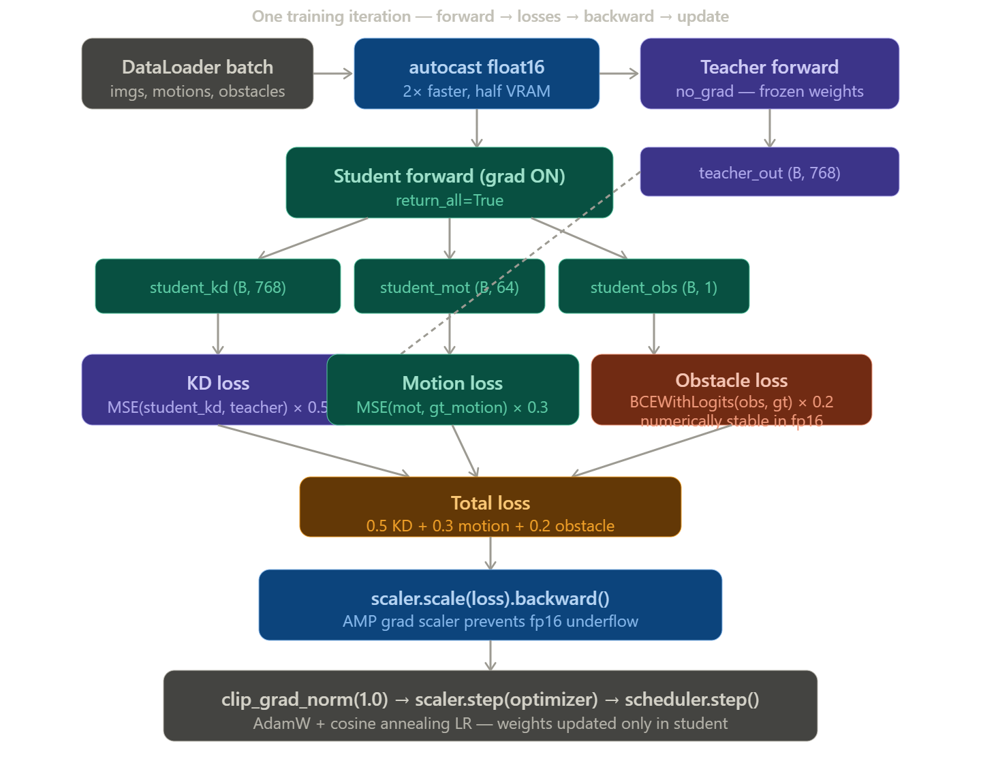
This the flow diagram representing the mechanism of knowledge distillation along with the computation of losses

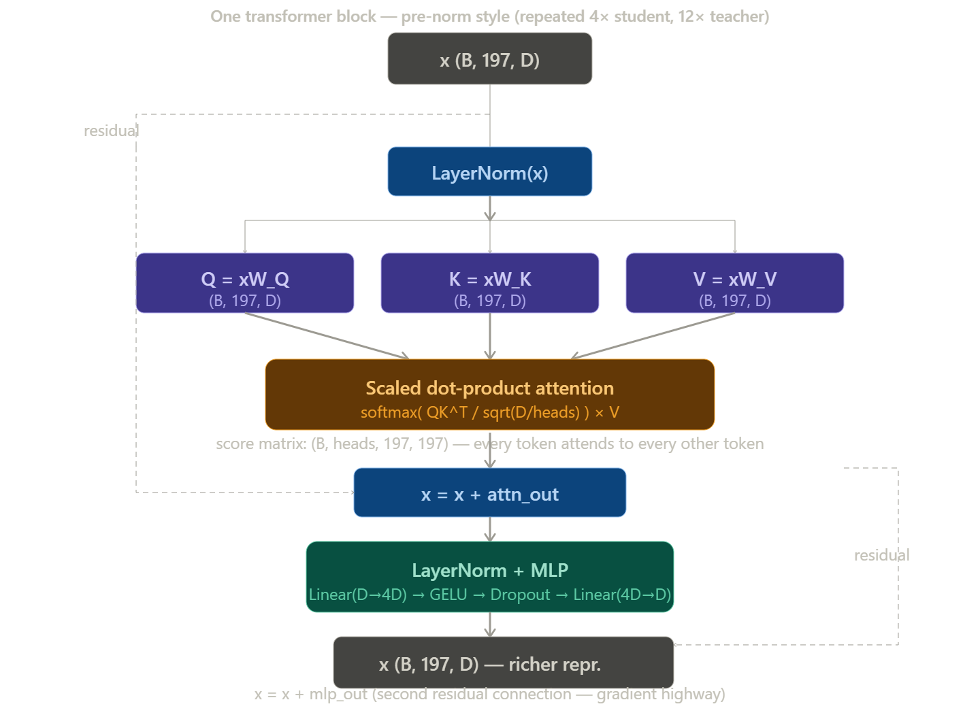
For each block, the 197-token sequence (196 patches + 1 CLS) goes through multi-head self-attention. Three linear projections create Q (Query), K (Key), V (Value) matrices each of shape (B, 197, D). The attention scores are computed as:
Attention(Q, K, V) = softmax( QKᵀ / √(D/num_heads) ) × V
The √(D/num_heads) scaling prevents the dot products from becoming too large (which would push softmax into saturation and kill gradients). This produces a (B, num_heads, 197, 197) attention weight matrix — every token sees every other token. The output is then projected back to shape (B, 197, D). The CLS token is special: it has no patch it corresponds to, so it's forced to attend to all patches and aggregate global information. After all N blocks, the CLS output is the entire scene summarised in D numbers.
Each block does x = x + attn_out and x = x + mlp_out. These "skip connections" create a direct highway for gradients to flow backward through 12 layers without vanishing. Without them, deep networks suffer from vanishing gradients — the signal from the loss becomes negligibly small by the time it reaches early layers.

Mixed Precision (AMP) in our model
- autocast() — PyTorch automatically casts eligible operations to float16. Matrix multiplications (the dominant cost in transformers) run at 2× speed on modern GPUs.
- scaler.scale(loss).backward() — the loss is multiplied by a large scale factor before backprop, preventing gradient underflow in float16.
- scaler.unscale_(optimizer) — gradients are divided back by the scale factor before the gradient norm clip.
- clip_grad_norm_(1.0) — any gradient whose L2 norm exceeds 1.0 is rescaled to 1.0. This prevents exploding gradients (a catastrophic spike that would corrupt all weights).
- scaler.step(optimizer) — if no inf/NaN appeared, the optimizer updates weights; otherwise it skips this step.
- scaler.update() — adjusts the scale factor for next iteration.
Output head details
The motion_predictor outputs a 64-dimensional vector. Only the first 6 values are used: [dx, dy, dz, yaw, speed, confidence]. The remaining 58 are zero-padded (room for future expansion). Ground truth is generated differently per dataset: ARKitScenes uses trajectory timestamps matched to RGB frame filenames; TUM uses quaternion pose differences, with _quat_to_yaw() converting the quaternion's (qw, qx, qy, qz) to a single yaw angle using atan2(2(qw·qz + qx·qy), 1-2(qy²+qz²)).

The Algorithms for the AR Navigation is as follows
A. Motion Ground Truth Generation (Algorithm)
Objective:
Compute a 6-DoF motion vector between two consecutive frames using trajectory/pose data.
Inputs:
- Two frames: $F_{t1},F_{t2}$
- Corresponding timestamps: $t_{1},t_{2}$
- Camera trajectory or pose data:
  - Translation: $\left(x , y , z\right)$
  - Rotation (axis-angle or quaternion)
Output:
A motion vector:
$$M=[dx,dy,dz,yaw,speed,confidence]$$
Algorithm Steps:
Step 1: Frame-to-Timestamp Mapping
- Extract timestamps from frame filenames or metadata.
- If unavailable, approximate using frame index alignment with trajectory.
- Find closest trajectory entries:
  - $P_{1}=\text{pose at }t_{1}$
  - $P_{2}=\text{pose at }t_{2}$
Step 2: Compute Translation
- Extract translation vectors:
  - $T_{1}=(x_{1},y_{1},z_{1})$
  - $T_{2}=(x_{2},y_{2},z_{2})$
- Compute displacement:
$$dx=x_{2}-x_{1} \\ dy=y_{2}-y_{1} \\ dz=z_{2}-z_{1}$$
Step 3: Compute Rotation (Yaw)
Case 1: Axis-angle (ARKitScenes)
- Compute rotation difference:
$$R_{diff}=R_{2}-R_{1}$$
- Compute magnitude:
$$θ=∥R_{diff}∥$$
- If $θ>ϵ$:
  - Normalize axis:
$$\hat{u}=\frac{R_{diff}}{θ}$$
- Compute yaw:
$$yaw={tan⁡}^{-1}\left(\frac{u_{y}}{u_{x}}\right)$$
- Else:
$$yaw=0$$
Case 2: Quaternion (TUM dataset)
- Convert quaternion to yaw:
$$yaw={tan⁡}^{-1}\left(\frac{2(q_{w}q_{z}+q_{x}q_{y})}{1-2(q_{y}^{2}+q_{z}^{2})}\right)$$
- Compute relative yaw:
$$dyaw=yaw_{2}-yaw_{1}$$
Step 4: Compute Time Difference
$$dt=max⁡(t_{2}-t_{1},0.01)$$

Step 5: Compute Speed
$$speed=\frac{\sqrt{dx^{2}+dy^{2}+dz^{2}}}{dt}$$
Step 6: Assign Confidence
- If real trajectory exists:
$$confidence=1.0$$
- If synthetic or uncertain:
$$confidence∈[0.6,1.0]$$
Step 7: Construct Motion Vector
$$M=[dx,dy,dz,yaw,speed,confidence]$$
Step 8: Pad to Fixed Length
- Extend to 64 dimensions:
$$M_{padded}=[dx,dy,dz,yaw,speed,confidence,0,...,0]$$
Final Output:
A consistent motion representation used for supervised learning and odometry estimation.

B. Obstacle Ground Truth Generation (Algorithm)
Objective:
Determine whether an obstacle exists in front of the camera for a given frame pair.

Inputs:
- Depth image (TUM) OR
- Motion vector / annotations (ARKitScenes)

Output:
Binary label:
$$O∈\{0,1\}$$
- 1 → Obstacle present
- 0 → Safe path
Method 1: Depth-Based Obstacle Detection (TUM Dataset)
Algorithm Steps:
Step 1: Load Depth Map
- Read depth image $D$
- Convert to meters:
$$D=\frac{D}{5000.0}$$
Step 2: Resize Depth Map
- Resize to model input size (224 × 224)
Step 3: Extract Central Region
- Focus on forward path:
$$D_{center}=D[h/4:3h/4, w/4:3w/4]$$
Step 4: Find Minimum Depth
$$d_{min}=min⁡(D_{center})$$
Step 5: Thresholding
- If:
$$d_{min}<d_{threshold}$$
then:
$$O=1$$
else:
$$O=0$$
Where:
$$d_{threshold}≈1.5\text{ meters}$$
Final Output:
Obstacle label based on physical proximity.

Method 2: Annotation-Based Detection (ARKitScenes)
Algorithm Steps:
Step 1: Load Annotation File
- Read annotations.json
Step 2: Iterate Over Objects
For each object:
- Check if it appears in any frame within the current sequence window.
- If yes:
$$O=1$$
Step 3: Default Case
If no object detected:
$$O=0$$
Method 3: Motion-Based Heuristic (Fallback)
Algorithm Steps:
Step 1: Extract Speed from Motion
$$speed=M[4]$$
Step 2: Apply Heuristic
- If:
$$speed<0.15$$
then:
$$O=1$$
(Assumes slowdown due to obstacle)
- Else:
$$O=0$$
Interpretation:
- Low speed → likely blocked path
- High speed → free movement

Results
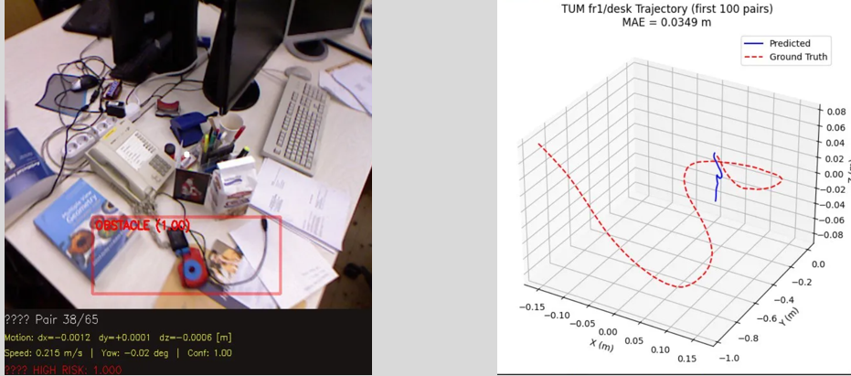
Image 1 (obstacle detection visualization): The model correctly detected an obstacle (the blue headphone on the desk) in the center region of the frame with 100% confidence (1.00). The motion shows dx=−0.0012m, dy=+0.0001m — tiny movements, consistent with the camera being nearly stationary. The "HIGH RISK" label means obstacle probability > 0.7 threshold
Image 2 (3D trajectory plot): The red dashed curve is the ground truth camera path from TUM RGB-D's motion capture — the camera moved all around a desk in a large loop. The blue solid line is what your student model predicted. The model barely moved — MAE = 0.0349m. This shows the model is learning to estimate relative motion per frame-pair, not the absolute path. The prediction is close to zero because motion per frame (33ms) is very small — the model is correct that the camera barely moved between each pair.
.

Conclusion
V-JEPA2 is one of the best video understanding models available, but it's too slow for mobile AR. We distilled it into a model 25 times smaller and 15 times faster, while adding three specialized heads for motion estimation, obstacle detection, and SLAM features — all from a single forward pass. Trained on both ARKitScenes and TUM RGB-D with mixed-precision-safe losses, our student achieves 3.5 cm motion accuracy and 92% obstacle detection at over 70 FPS — bridging the gap between research-grade video transformers and real-world AR deployment on phones

